REPORT
to the
CHICAGO PLAN COMMISSION
from the

DEPARTMENT OF PLANNING AND DEVELOPMENT
OCTOBER 20, 2016

APPLICANT: WILLIAMS ELECTRONIC GAMES, INC.

LOCATION: 3401 NORTH CALIFORNIA AVENUE

FOR APPROVAL: AMENDMENT TO INDUSTRIAL PLANNED DEVELOPMENT #1151

INTRO DATE: SEPTEMBER 14, 2016

PD THRESHOLD: MANDATORY (AMENDMENT) TO PLANNED DEVELOPMENT – PROPOSED CHANGE TO ALLOW REQUIRED OFF-STREET ACCESSORY PARKING TO BE LOCATED OFF-SITE RESULTING IN A CHANGE OF CHARACTER (SECTION 17-13-0611)

PROJECT SUMMARY
Industrial Planned Development #1151 (IPD #1151) was created in 2009 and consists of the home of WMS Gaming, a manufacturer of casino video gaming systems. WMS Gaming employs approximately 600 individuals in a 240,000 square foot facility at 3401 N. California Avenue. The most recent addition to the facility was completed in 2012. The company traces its’ origins back to the 1940’s when it originally was engaged in the manufacture of arcade games.

When IPD #1151 was created, it included a requirement of 329 parking spaces, however, IPD #1151 did not specify a location for the required parking. In the intervening years, WMS has utilized nearby surface parking areas to meet the needs of its employees and the requirements of the planned development. By the end of 2016, a significant portion of the surface parking that WMS had been using will no longer be available. The proposed Amendment identifies two locations outside of the planned development that will provide a long term parking solution for WMS. The parcel at 2703-25 West Roscoe Street is an existing parking lot that is located within Planned Development #651 and has 260 spaces. The parcel at 3231-3323 North California Avenue is currently vacant but is planned to be improved to accommodate 170 automobiles. Together, these off-site locations will contain space for 430 automobiles, well in excess of the required parking for IPD #1151.

ZONING CONTEXT (existing IPD #1151):
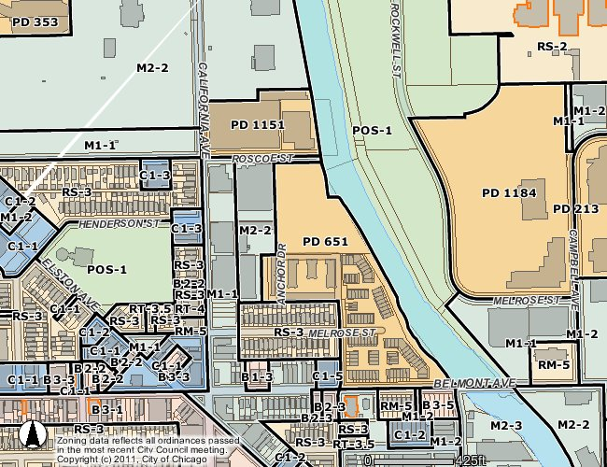

PROPOSED OVERVIEW

RECOMMENDATION
The Department of Planning and Development has reviewed the project materials submitted by the Applicant and compared this proposal to existing development in the community. The area around this project consists generally of a mixed industrial and residential neighborhood in Chicago’s Avondale Community Area.

Based on that analysis, the Department of Planning and Development has concluded that this Amendment to IPD #1151 is appropriate for this site and supports this development for the following reasons:

- The proposed rezoning of the subject property is appropriate under Chapter 17-13 of the Zoning Ordinance. Specifically, the Amendment is 1) consistent with plans for the area, including the Addison Corridor North Tax Increment Financing Area Land Use Plan and the Addison Industrial Corridor (17-13-0308-A); 2) compatible with the character of the surrounding area in terms of uses, density and building scale (17-13-0308-C), and; 3) compatible with surrounding zoning districts (17-13-0308-D).

- The project meets the purpose and criteria set forth in Chapter 17-8 of the Zoning Ordinance and its adoption would not have any adverse impact on the public’s health, safety or welfare. Specifically, this project meets the following provisions of Chapter 17-8:

  - Encourages unified planning and development (per 17-8-0102), as evidenced by the identification of specific locations for required off-street parking that will serve the primary office/industrial use within IPD #1151;
  - Promotes economically beneficial development patterns that are compatible with the character of existing neighborhoods (per 17-8-0103) as evidenced by the compatibility of off-street parking within the broader industrial park character of the surrounding area;
  - Further encourages the use of shared parking (per 17-8-0904-C3) as demonstrated by the ability of the parking area located at 2703-2725 West Roscoe Street to be shared with other buildings located outside of PD # 651; and,
  - Upon completion, all parking lots will fully comply with the Chicago Landscape Ordinance.

Based on the foregoing, it is the recommendation of the Department of Planning and Development that this application for a Residential Business Planned Development be approved and that the recommendation to the City Council Committee on Zoning, Landmarks and Building Standards be “Passage Recommended”.

Bureau of Zoning and Land Use, Department of Planning and Development

